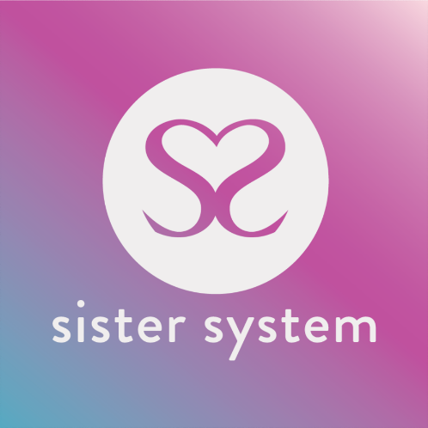

CONFIDENTIAL SISTER SYSTEM PARENT/GUARDIAN FORM

Address: Studio 31, The Trampery, 639 High Road, London, N17 8AA

Email: programmes@sistersystem.org

Telephone: +44 07763 008018

Web: www.sistersystem.org

This form will be held in confidence but may be shown to the Young Person if requested. Have you discussed this referral with the Young Person prior to completing this form? YES ☐ / NO ☐

WE ARE UNABLE TO PROCESS YOUR REFERRAL UNTIL WE RECEIVE THIS FORM FULLY COMPLETED

YOUNG PERSON’S DETAILS:

Name of Young Person: |  | DOB:
Referral date: |  | Address:

Telephone contact for Young Person or please state the name and person/role we should contact in regards to contacting Young Person (please ensure that you have their permission to disclose)

Your young person’s details: |  | Number:
Ethnicity of young person: |  | E- mail:
Immigration status of Young Person: |  | Sexual orientation of Young Person:
Young Person’s Medical Contact Details:
GP Name and Address: |  |  | Contact Number:
Health Visitor’s Name and Address |  |  | Contact Number:

Please tick any of the relevant boxes applicable to the young person:

In School ☐ | In College ☐ | At University ☐
Not in Education or Training ☐ | Unemployed ☐ | Employed ☐

Can we make contact with the young person at this stage? _________________
How long has the young person been living with you for? _______________________________________________

CARER/PARENT MAKING REFERRAL:

Name: |  | Address:
Email: |  | Contact Number:
Role (please highlight relevant answer): | Foster Parent/ Parent / Guardian/ Extended Family Member

Emergency Contact Details (Optional)

Name: |  | DOB (optional):
Contact Number: |  | Address (Optional):

Relationship to you: |  | Contact Number:

Has the Young Person ever been affected by any of the below issues? (Please tick all relevant boxes)

Child Sexual Exploitation ☐ | Domestic abuse ☐ | Teenage pregnancy ☐
Mental health issues ☐ | Substance abuse ☐ | Learning disabilities ☐
Post-natal depression ☐ | Child Criminal Exploitation ☐ | Drug trafficking ☐
Sex Trade ☐ | Controlled or coerced ☐ | Modern slavery ☐

Rape ☐ | Physical Abuse☐ | Other____________________________ ☐

Does the Young Person have any of the below mental health challenges? (Please tick all relevant boxes)

Depression ☐ | Anxiety ☐ | Bipolar ☐
Extreme Stress ☐ | Hypermania ☐ | Loneliness ☐
Anger ☐ | Bereavement ☐ | Panic Attacks ☐
Sleeplessness ☐ | Anything else? (Please note)  _______________________________________________

Anything else please to note?
________________________________________________________________________________________________________________________________________________________________________________________________________________________________________________________________________________________________________________________________________________________________________________________________________________________________________________________________________________________________________________________

Does the young person have challenges with drugs or alcohol? yes/no (please indicate)
If ‘yes’ which drugs please specify:
________________________________________________________________________________________________________________________________________________________________________________________________________________________________________________________________________________________________________________________________________________________________________________________________________________________________________________________________________________________________________________________

Whilst in your care has the young person presented any behavioral challenges? If so, please explain in brief.
________________________________________________________________________________________________________________________________________________________________________________________________________________________________________________________________________________________________________________________________________________________________________________________________________________________________________________________________________________________________________________________

How would you describe your relationship with the young person?

Excellent ☐ | Good ☐ | Poor/Challenging ☐

What support do you think you would need from the Sister System? (If you are unsure at this stage don’t worry, we can discuss this together).

________________________________________________________________________________________________________________________________________________________________________________________________________________________________________________________________________________________________________________________________________________________________________________________________________________________________________________________________________________________________________________________

Please give details of any other agencies currently working with you:

Agency | Lead Person | Email Address | Phone Number

ADDITIONAL INFORMATION

Please add any background information that you think is important for us to know e.g., Safeguarding and/or H&S concerns: (if necessary, please attach an extra sheet)

SIGNATURE & DECLARATION

Name: |  | Signature: |  | Date:

Thank you for completing this foster parent, parent, guardian, extended family referral form. Please email it to programmes@sistersystem.org or alternatively post it to our office’s address at the top of this form.

Next Steps - On receipt of this referral please expect a phone call within 5 days/unless urgent from one of our sisters who will arrange to speak with you which can either be done remotely or social distancing face-face.

