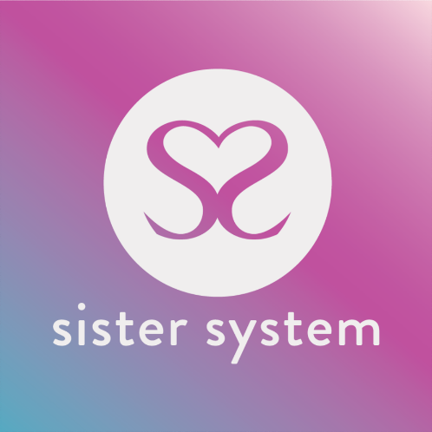
CONFIDENTIAL SISTER SYSTEM PROFESSIONAL REFERRAL FORM

Sister System: Studio 31, The Trampery, 639 High Road, London, N17 8AA
Email: programmes@sistersystem.org
Telephone: 07763 008018
Web: www.sistersystem.org

All referrals must be made with the consent of the Young Person. This form will be held in confidence but may be shown to the Young Person if requested. Have you discussed this referral with the Young Person to completing this form? YES ☐ / NO ☐

WE ARE UNABLE TO PROCESS YOUR REFERRAL UNTIL WE RECEIVE THIS FORM FULLY COMPLETED

Young Persons Details

Name of Young Person: |  | DOB:
Referral date: |  | Address:

Telephone contact for Young Person or please state the name and person/role we should contact regards to contact Young Person (please ensure that you have their permission to disclose)

Person: |  | Number:
Ethnicity of young person: |  | E- mail:
Immigration status of Young Person: |  | Sexual orientation of Young Person:

Referrer’s Details

Name & Role: |  | Agency:
Email: |  | Phone Number:
Agency Address:

Key Information

Place of Residence
Independent Accommodation ☐ | Family Home ☐ | Children’s Home ☐
Semi-independent accommodation ☐ | Foster Care ☐ | Other:

Please give details of any other agencies currently working with this Young Person:

Agency | Lead Person | Email Address | Phone Number

Family Doctor Details
Address: |  | Phone Number:
Health Visitor Details
Address: |  | Phone Number:

Please tick all those apply to this Young Person:
Child Sexual Exploitation ☐ | Domestic abuse ☐ | Teenage pregnancy ☐
Mental health issues ☐ | Substance abuse ☐ | Learning disabilities ☐
Post-natal depression ☐ | Child Criminal Exploitation ☐ | Drug trafficking ☐
Sex Trade ☐ | Controlled or coerced ☐ | Modern slavery ☐

Have you visited the family home? YES ☐ / NO ☐
Please tell us about any Health and Safety issues that we need to consider if collecting a young person from the residing home:

Young Person’s Needs

So that we can offer the most appropriate support, and match the most suitable coaches, please complete the following table. Please note this is not a ‘points’ system. Young People will not be prioritised based on how many categories are ticked. This information, together with information provided by the family, will be used to monitor how our support best meets the needs of the Young Person.

Identified Need (please tall all that apply) | Why is this a need?
Resilience development ☐
Risk awareness ☐
Career/training development ☐
Family needs ☐
Managing child’s behaviour ☐
Being involved in the child(ren)’s development ☐
Coping with own physical health ☐
Coping with own mental health ☐
Coping with feeling isolated ☐
Parent’s self-esteem ☐
Coping with child’s physical health ☐
Coping with child’s mental health ☐
Managing the household budget ☐
The day-to-day running of the house ☐
Stress caused by conflict in the family ☐
Coping with multiple birth/multiple children under 5 ☐
Use of services ☐
Other (please describe) ☐

Details of household members with caring responsibilities for the children:
Who does the young person is resides with: |  | Gender:
Date of birth: |  | Ethnicity:
Sexual orientation: |  | Immigration status:

Additional Information

Please add any background information that you think is important for us to know e.g., Safeguarding and/or H&S concerns: (if necessary, please attach an extra sheet)

Signature & Declaration

Referrer’s Name: |  | Signature: |  | Date:
Young Person’s Name: |  | Signature (optional): |  | Date:

Thank you for taking time to provide this information which will help us to process the referral.
We are unable to process your referral until we have received this form. We try to respond to all referrers within 2 weeks of receiving the referral to report progress. We will remain in touch while supporting this young person and will contact you when the support ends. If you have any issues or concerns about the referral process or the support for the young person please contact Tanya Nelson, Programme Manager, at the above address on the above-mentioned email.

