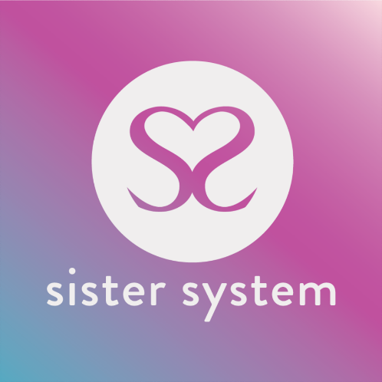

CONFIDENTIAL SISTER SYSTEM SELF-REFERRAL FORM
Address: Studio 31, The Trampery, 639 High Road, London, N17 8AA
Email: referrals@sistersystem.org
Telephone: +44 07763 008018
Web: www.sistersystem.org

WE ARE UNABLE TO PROCESS YOUR REFERRAL UNTIL WE RECEIVE THIS FORM FULLY COMPLETED

PERSONAL DETAILS:

Name: |  | DOB:
Referral date: |  | Address:

Sexual Orientation: |  | Contact Number:
Ethnicity: |  | E- mail:
Immigration status: |  | How did you hear of Sister System?

A person you would like contacted in case of emergency:

Name: |  | Relationship to you:
Contact Number: |  | Address (Optional):

KEY INFORMATION:

Place of Residence (kindly tick relevant box)
Independent Accommodation ☐ | Family Home ☐ | Children’s Home ☐
Semi-independent accommodation ☐ | Foster Care ☐ | Other:

Please give details of any other agencies currently working with you:

Agency | Lead Person | Email Address | Phone Number

Medical Contact Details:
GP Name and Address: |  |  | Contact Number:
Health Visitor’s Name and Address |  |  | Contact Number:

Are you a survivor of?

Child Sexual Exploitation ☐ | Domestic abuse ☐ | Teenage pregnancy ☐
Mental health issues ☐ | Substance abuse ☐ | Learning disabilities ☐
Post-natal depression ☐ | Child Criminal Exploitation ☐ | Drug trafficking ☐
Sex Trade ☐ | Controlled or coerced ☐ | Modern slavery ☐

Rape ☐ | Physical Abuse☐ | Other____________________________ ☐

Have you ever experienced?

Depression ☐ | Anxiety ☐ | Bipolar ☐
Extreme Stress ☐ | Hypermania ☐ | Loneliness ☐
Anger ☐ | Bereavement ☐ | Panic Attacks ☐
Sleeplessness ☐ | Anything else? (Please note)  _______________________________________________

PERSONAL NEEDS

So that we can offer the most appropriate support, and match the most suitable coaches, please complete the following table. Please note this is not a ‘points’ system. Answers will not be prioritized based on how many categories are ticked. This information, will be used to monitor how our support best meets your needs and expectations. **If you are unsure at this stage, do not worry we can discuss this together**

Identified Need (please tick all that apply) | Why is this a need?
Resilience development ☐
Risk awareness ☐
Career/training development ☐
Family needs ☐
Managing your behaviour ☐
Being involved in the child(ren)’s development ☐
Coping with own physical health ☐
Coping with own mental health ☐
Coping with feeling isolated ☐
Parent’s self-esteem ☐
Coping with your physical health ☐
Coping with your mental health ☐
Managing the household budget ☐
The day-to-day running of the house ☐
Stress caused by conflict in the family ☐
Coping with multiple birth/multiple children under 5 ☐
Use of services ☐
Other (please describe) ☐

Do you think you have challenges with drugs or alcohol? yes/no (please indicate)
If ‘yes’ which drugs please specify: _____________________________________

MORE ABOUT YOURSELF

Please state if you are:

In School ☐ | In College ☐ | At University ☐
Not in Education or Training ☐ | Unemployed ☐ | Employed ☐

Do you have any hobbies and/or interests? (Please share with us)

________________________________________________________________________________________________________________________________________________________________________________________________________________________________________________________________________________________________________________________________________________________________________________________________________________________________________________________________________________________________________________________

What support do you think you would need from Sister System? (If you are unsure at this stage don’t worry, we can discuss this).

________________________________________________________________________________________________________________________________________________________________________________________________________________________________________________________________________________________________________________________________________________________________________________________________________________________________________________________________________________________________________________________

What programme/s interests you (please refer to website: sistersystem.org for more information)?
________________________________________________________________________________________________________________________________________________________________________________________________________________________________________________________________________________________________________________________________________________________________________________________________________________________________________________________________________________________________________________________

Can you tell us how the care system has affected you?

________________________________________________________________________________________________________________________________________________________________________________________________________________________________________________________________________________________________________________________________________________________________________________________________________________________________________________________________________________________________________________________

ADDITIONAL INFORMATION:

Please add any background information that you think is important for us to know.
(If you would like to speak with us about any of the above, that's also fine).

SIGNATURE & DECLARATION

Name: |  | Signature: |  | Date:

Thank you for completing this self-referral form, please email it to referrals@sistersystem.org or alternatively post it to our offices, address at the top of this form.

Next Steps - On receipt of this referral please expect a phone call within 5 days/unless urgent from one of our sisters who will arrange to speak with you which can either be done remotely or social distancing face-face.

